A MINI- PROJECT REPORT ON

“CATARACT DETECTION AND CLASSIFICATION”

SUBMITTED BY

Kaushal Chande(17IT1012)

Piyush Jha(17IT1027)

Kamaljit Kaur (17IT2039)

Supervisor

Mr. SWAPNIL SHINDE


Department of Information Technology Dr. D.Y.Patil Group's
Ramrao Adik Institute of Technology

Nerul, Navi Mumbai (Affiliated to University of Mumbai)

(2020)

Abstract

Survey done by world health organization for probing causes of blindness indicates that cataract is major cause of blindness. Even age-related cataract is most commonly observed, it is serious cause to think because of its appearance in minors and children for both eyes. Detecting cataract at earlier stage is challenge as it has less affecting vision. The three most general types of cataract are nuclear cataract, cortical cataract and post subcapsular cataract. Conventional methods of cataract diagnoses include slit lamp image test by doctors which does not prove to be effective in classifying cataract in the early stages and can also have inaccuracies in identifying the correct type of cataract. Existing work to automate the process have worked on classification based upon binary detection only or have considered only one type of cataract among the mentioned types for further expanding the system. Our system works on detection and classification of cataract on three major types as mentioned above in an attempt to reduce errors of manual detection of cataract in the early ages. Our proposed system has successful classified image as cataract affected or as a normal eye with an accuracy of 96% using combined feature vector from SIFT-GLCM algorithm applied to classifier models of SVM, Random forest and Logistic Regression. The effect of using SIFT and GLCM separately have also been studied which leads to comparatively lesser accuracies in the model trained.

Contents
Abstract 2
- Introduction 4
- Literature Survey 10
- Problem Statement 21
- Objective 22
- Proposed Framework 23
- Conclusion 25
- References 26

- Introduction

A cataract is a progressive cloudiness, hardening, and yellowing of the normally transparent lens of the eye. Cataracts occur when the normally clear lens of the eye becomes cloudy, restricting the amount of light that reaches the retina, leading to a decrease in vision.

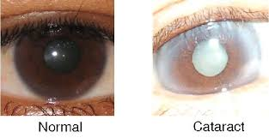
Fig 1.Normal Eye vs Cataract Eye [1]
According to World health organization(WHO) at On World Sight Day 2019 about 36 million people were recorded blind and 217 million people with moderate or severe distance vision impairment(MSVI). Of those with blindness and MSVI, 124 million people have uncorrected refractive errors and 65 million had cataract. Thus, the condition of cataract is responsible for 48% of world blindness [2].
According to the National blindness and Visual Impairment Survey India 2015-19, this condition is behind 66.2 per cent blindness cases, 80.7 per cent severe visual impairment cases and 70.2 per cent moderate visual impairment cases in the age group of 50+ years of age [3].
Most cataracts develop slowly and don't disturb your eyesight early on. But with time, cataracts will eventually interfere with your vision. At first, the cloudiness in your vision caused by a cataract may affect only a small part of the eye's lens and you may be unaware of any vision loss. As the cataract grows larger, it clouds more of your lens and distorts the light passing through the lens. This may lead to more noticeable symptoms.
- SIGNS AND SYMPTOMS
- Clouded, blurred or dim vision.
- Increasing difficulty with vision at night.
- Sensitivity to light and glare.
- Need for brighter light for reading and other activities,
- Seeing "halos" around lights.
- Frequent changes in eyeglass or contact lens prescription.
- Fading or yellowing of colors.
- Double vision in a single eye.

- CAUSES AND RISK FACTORS:
- Ultraviolet radiation
- Diabetes
- Hypertension
- Obesity
- Smoking
- Prolonged use of corticosteroid medications
- Statin medicines used to reduce cholesterol
- Previous eye injury or inflammation
- Previous eye surgery
- Hormone replacement therapy
- Significant alcohol consumption
- High myopia
- Family history
- Age [4]
TYPES OF CATARACT:
- Cataracts affecting the center of the lens (nuclear cataracts). A nuclear cataract may at first cause more near sightedness or even a temporary improvement in your reading vision. But with time, the lens gradually turns more densely yellow and further clouds your vision. As the cataract slowly progresses, the lens may even turn brown. Advanced yellowing or browning of the lens can lead to difficulty distinguishing between shades of color [4].
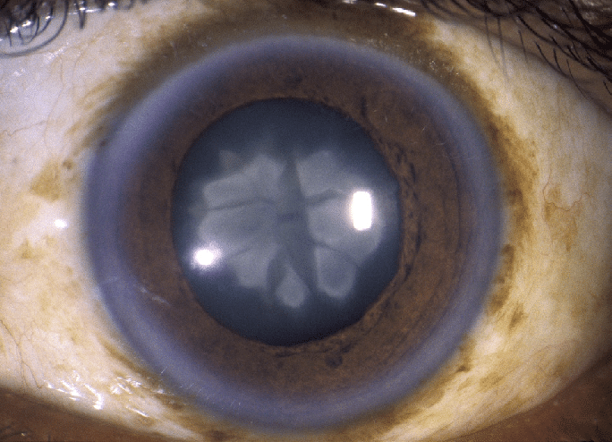
Fig.2- Nuclear Cataract [5]
- Cataracts that affect the edges of the lens (cortical cataracts). A cortical cataract begins as whitish, wedge-shaped opacities or streaks on the outer edge of the lens cortex. As it slowly progresses, the streaks extend to the center and interfere with light passing through the center of the lens [4].
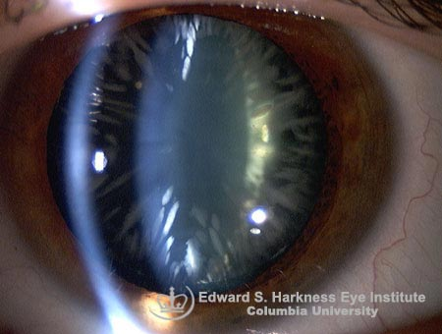
Fig 3. Cortical Cataract [6]

- Cataracts that affect the back of the lens (posterior subcapsular cataracts). A posterior subcapsular cataract starts as a small, opaque area that usually forms near the back of the lens, right in the path of light. A posterior subcapsular cataract often interferes with your reading vision, reduces your vision in bright light, and causes glare or halos around lights at night. These types of cataracts tend to progress faster than other types do [4].

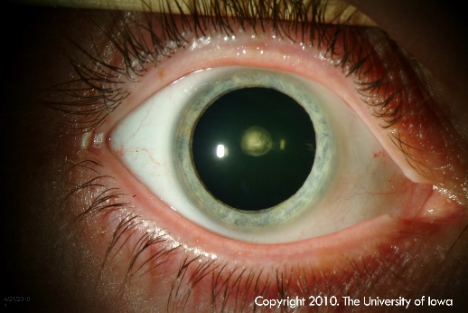
Fig 4. Posterior subcapsular cataracts [7]
DIAGNOSES OF CATARACT:
- Visual acuity test. A visual acuity test uses an eye chart to measure how well you can read a series of letters. Your eyes are tested one at a time, while the other eye is covered. Using a chart or a viewing device with progressively smaller letters, your eye doctor determines if you have 20/20 vision or if your vision shows signs of impairment [4].
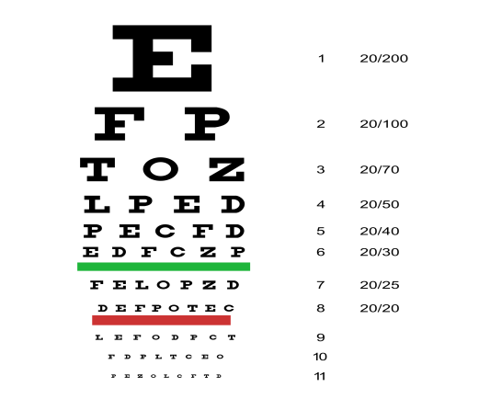
Fig 5.Chart used for acuity test [8]
- Slit-lamp examination. A slit lamp allows your eye doctor to see the structures at the front of your eye under magnification. The microscope is called a slit lamp because it uses an intense line of light, a slit, to illuminate your cornea, iris, lens, and the space between your iris and cornea. The slit allows your doctor to view these structures in small sections, which makes it easier to detect any tiny abnormalities [4].
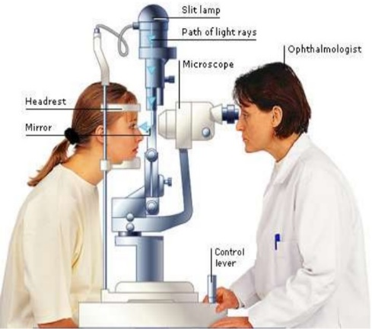
Fig 6.Slit-lamp examination [9].
.
- Retinal exam. To prepare for a retinal exam, your eye doctor puts drops in your eyes to open your pupils wide (dilate). This makes it easier to examine the back of your eyes (retina). Using a slit lamp or a special device called an ophthalmoscope, your eye doctor can examine your lens for signs of a cataract [4].
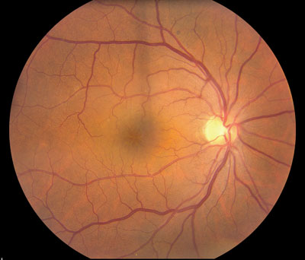
Fig 7. Fundus image obtained after retinal exam [10]

Current work in the field:

In reference to the various research papers one of which published in Journal of Network Communications and Emerging Technologies mentioning about work Automatic Cataract Detection Analysis Using Image Processing which uses MATLAB to study the various retinal images and give out a binary output if the patient has cataract or not. The accuracy obtained is about 90% and further suggests to use SVM to improve the accuracy [11]. At a paper published in 2016 which also works on fundus retinal images, the RGB image is converted into green channel image and by applying image processing techniques, the contrast is enhanced and noise is removed. Binary SVM is implemented to classify the fundus image and for grading, MDA algorithm is applied. Classification is carried out for two classes i.e. non-cataract and cataract. Grading part consists of three classes i.e. mild, moderate and severe cataract. The dataset used is real-world dataset containing 261 images [12].

A system was using two different classes of algorithms are tested; (a) traditional computer vision approach of hand crafting features followed by developing machine learning (ML) models (b) automatic feature engineering and classification using more modern convolutional neural networks (CNN) to build model to identify cataract. A set of 600 pre labelled retinal scan images were used to train the models.[13] In reference to the various research papers one of which published in Journal of Network Communications and Emerging Technologies mentioning about work, proposed method is to detect cataract using a smartphone like Android, iOS, Windows. The camera detects two eyes, crop eyes on running time and shows the different layout in the camera view. When cropping the pupil from two eyes on running time, then two pupils are stored in a matrix. Analyze two matrices using the help of NDK, which provide C/C++ coding on android platform. Some color detection method is applied to detect the pupils color then take the decision, eyes are a cataract or not [14]. The two main features average or mean intensity of image and histogram are used to determine the presence of cataract in the patient [15].

Literature Survey

Machine Learning on Cataracts Classification Using SqueezeNet [16]

Difficult for old people in the countryside to receive the treatment on cataracts as soon as possible because of lack of well-experienced doctors and poor equipment, resulting in blindness of most patients
Classification of the three types of cataracts which are nuclear cataracts, cortical cataracts and posterior subcapsular cataracts

- What does the system do and how?

- Generated a classifying neural network model
- Pre-processing: cropping and image generating methods
- Trained new neural network layer on top of SqueezeNet, which is a pre-trained model that already achieved high accuracy on classifying images in ImageNet
- Tested for output

- Image Preprocessing:

Hough Circle Detection which is used to detect the circle part of one image
the images were resized into 224*224*3
Duplicating some images in Posterior Subcapsular Cataracts and removing some images in classes with larger number of images to create a balanced dataset for training
Image Data Generator is implemented in order to solve the problem of small dataset

- Training Model

To save the time on training and changing the model transfer learning method is used
Transfer learning is a machine learning method where a model developed for a task is reused as the starting point for a model on a second task
Squeeze Net model in order to classify and detect cataracts from nuclear cataracts, cortical cataracts, posterior cataracts and transparent lens.
Squeeze Net is one type of convolutional neural network (CNN), which achieves the same accuracy on classifying images from ImageNet as Alex Net but needs 50 times fewer parameters than Alex Net thus it was used.

Comparison of Ensemble Learning Algorithms for Cataract Detection from Fundus Images [17]

In this paper, they have compare ensemble machine learning algorithms for cataract detection from fundus images. Two different types of image features, extracted by texture-based and sketch-based methods, are used to build basic machine learning models. The ensemble machine learning algorithms, majority voting and stacking methods are then investigated by combining the base learning models for cataract detection to compare their performances. Steps involved:
a) Image Acquisition: Fundus images are collected from the database of Mettapracharak (Wat Rai Khing) Hospital, Nakhon Pathom, Thailand. Each fundus image is manually labeled by the ophthalmologist as normal (non-cataract), mild cataract, moderate cataract, or severe cataract.
b) Pre-processing: The retina fundus images are resized to 584×565 pixels before use in the experiments. Then, colour model selection is used to produce the best result for cataract classification. The green channel best shows the differences in light intensity of each component of the images, with the blood vessels being the most intense

c) Feature Extraction: This paper uses the texture-based and sketch-based methods to extract features from fundus images suitable for cataract detection.:
1) Texture-based Methods: Three types of texture features are extracted to represent the retina fundus image as the luminance feature, the gray co-occurrence matrix, and the gray-gradient co-occurrence matrix.
2) Sketch-based Methods: The sketch-based method extracts features from fundus images to build base classifiers for cataract detection
d) Detection: For each feature set, three basic machine learning algorithms as decision tree, back propagation neural network, and support vector machine are built for cataract detection. The retina fundus image pre-processing and feature extraction component are implemented with the image processing toolbox in MATLAB. They have use three features on Wat Rai Khing dataset which are the sketch, texture and mix (sketch and texture) Data mining software Weka is employed to construct the decision tree (DT), back propagation neural network (BPNN) and sequential minimal optimization (SMO). Then, the majority voting and the stacking are investigated to combine the classifiers for cataract detection.

Results:
Table no.1 Accuracy for various classifiers
Classifiers |  | Measures
 | Cataract | Non-cataract | Accuracy (%)
 | Sensitivity (%) | Specificity (%)
Sketch-DT | 91.429 | 100 | 94.415
Texture-DT | 94.286 | 96.183 | 94.947
Mix-DT | 94.286 | 96.183 | 94.947
Sketch-BPNN | 93.061 | 93.130 | 93.085
Texture-BPNN | 94.696 | 91.603 | 93.617
Mix-BPNN | 95.102 | 92.366 | 94.149
Sketch-SMO | 97.959 | 79.389 | 91.489
Texture-SMO | 95.102 | 85.496 | 91.755
Mix-SMO | 95.510 | 84.733 | 91.755

The result for DT classifier shows the highest accuracy rate at 94.947% as a mix feature set. The highest accuracy rate of BPNN classifier was 94.149%
Table no.2 Accuracy for various classifiers

Classifiers |  |  | Measures
 |  | Cataract | Non-cataract | Accuracy (%)
 |  | Sensitivity (%) | Specificity (%)
Sketch-Majority |  | 95.918 | 86.260 | 92.553
Texture-Majority |  | 95.918 | 88.550 | 93.351
Mix-Majority |  | 95.918 | 87.023 | 92.819
Sketch-Stacking |  | 91.429 | 100 | 94.415
Texture-Stacking |  | 93.878 | 96.183 | 95.479
Mix-Stacking |  | 93.878 | 97.710 | 95.213

The results of texture-stacking in Table II give best results of all other classification algorithms with the highest accuracy rate in the partition images at 95.479%.

Cataract detection and grading based on combination of deep
convolutional neural network and random forests [18]
Steps of the proposed methodology:
The model for cataract detection, classification and grading is mainly divided into 3 phases which are described as follows:
a) Pre-processing
b) DCNN feature extractor
c) RF grader
a) Pre-processing: Fundus images are captured by specialized fundus cameras. Pre-processing is based on fundus images, and it contains some common operations like desensitizing. The pre-processed images are divided into training dataset and testing dataset. In order to standardize the fundus images, specifications standardization have been used to get unified rectangular fundus images and general nonlinearity brightness adjustment to reduce the interference of different illumination
b) DCNN feature extractor: The main goal of the Feature Extraction process is to filter out the required features. This is done in 3 steps:
1) Shallow module: The features extracted are fundamental concepts such as edge information, brightness information and background texture information. Besides, the shallow module differentiates various features like optic disc and choroidal texture into feature maps.
2) Residual module: The medium features like spatial distribution and illumination are captured by residual module.
3) Pooling module: The pooling module in Figure 9 is a simple average pooling layer for data dimension reduction and over-fitting prevention
c) Random Forests grader: This is the last phase of the proposed method where RF implements more elaborate six-level cataract grading based on the feature datasets generated by DCNN. The six-level grading allows doctors to understand the patient condition more accurately than four-level grading
Results:
Table No.3 Cataract detection results of DCNN-RF
Results\Indicators | S_{e} (%) | S _{p} (%) | S_{a} (%)
Results | 97.26 | 96.92 | 97.04
where Sa, Se, S p represent accuracy, sensitivity and specificity respectively.
Table no.4 Cataract grading on six-level criterion by DCNN-RF
 | Grades |  | Non- |  |  |  | Slightly mild |  |  |  | Mild |  |  |  | Medium |  |  |  | Slightly |  |  |  | Severe
 |  |  | cataractous |  |  |  |  |  |  |  |  |  |  |  |  |  |  |  | severe |  |  |  |  |  |  | S_{a}
 | Indicators |  | S_{e} |  | ^{S} p |  | S_{e} |  | ^{S} p |  | S_{e} |  | ^{S} p |  | S_{e} |  | ^{S} p |  | S_{e} |  | ^{S} p |  | S_{e} |  | ^{S} p | (%)
 |  |  | (%) |  | (%) |  | (%) |  | (%) |  | (%) |  | (%) |  | (%) |  | (%) |  | (%) |  | (%) |  | (%) |  | (%)
 | Results
 |  |  | 95.89 |  | 98.15 |  | 88.96 |  | 96.13 |  | 76.31 |  | 98.15 |  | 85.22 |  | 98.05 |  | 87 |  | 98.69 |  | 99.5 |  | 99.34 | 90.69
. Experiments show that this method achieves 97.4% average detection accuracy, 90.64% grading accuracy and good performance on both sensitivity and specificity.

Early Recognition and Grading of Cataract using a Combined Log Gabor/Discrete Wavelet Transform with ANN and SVM [19]

The model for cataract detection, classification and grading is mainly divided into 3 phases which are described as follows:
a) Pre-processing
b) Feature Extraction
c) Classification
a) Pre-processing: In the Pre-processing stage, the main goal is to remove all the unnecessary information from the image. This is done by the resizing of the image, cleaning the images. This includes removing glare from the images and also converting them into grayscale form.
b) Feature Extraction: The main goal of the Feature Extraction process is to filter out the required features. Now in this situation, the main feature is extracting the image of eye lens. Therefore, an invisible circle is made and only the part of image containing the pupil is extracted in this process. After the extraction, it is then given to the wavelet transform with Log Gabor filters to obtain the feature vectors.
c) Classification: This is the last phase of the proposed method where in the feature vectors which are obtained after performing the Wavelet Transform are sent to both the support machines SVM and ANN. Both of these machines classify the images into three classes: normal, early stage and advanced stage. Here the first class refers to the normal eyes having no sign of cataract, the second class refers to the eyes which are having cataract but it is in the early stages and the last class refers to the eyes in which the cataract has reached the advanced stage.
Results:
The results of both the machines are shown below showing the accuracy of each classifier used in this method:
Table no. 5 Accuracy for the algorithms
Feature Extraction Techniques | Classifiers | Accuracy
DWT + Log Gabor | SVM | 96.8%
DWT + Log Gabor | ANN | 92.3%

The above results show the accuracy of SVM classifier as 96.8% and accuracy of ANN classifier as 92.3% on a dataset of 120 images.

Future Work:
- Work on larger datasets
- Create a mobile and web application providing easy access to the patients.
- To provide a communication between the patients and ophthalmology clinics.
- Live video conversations between the patient and ophthalmologist to save time and money.

Mobile Application Based Cataract Detection System [20]

Steps of the proposed methodology:
This method is basically based upon using the algorithms of Machine Learning and Image Processing together.
The Overall methodology is divided into four steps as follows:
a) Collection of Images
b) Pre-processing of Data
c) Classification by KNN
d) Validation of Developed Application
a) Collection of Images: The data is collected from the google image database by writing a script on JAVA. The Google API using AJAX is being embedded in the application to download the cataract eye images and normal eye images.
b) Pre-processing of Data: The downloaded images are then cropped in order to get only the interesting area of the image. The cropped image is now shown to the user to verify that image has been cropped appropriately. The image is now fed to the Orange Tool for the process of feature extraction. About 2048 features of the image are extracted with its size and dimensions. Now the dataset is classified into 2 categories Cataract and Normal and both of them are being merged into one .csv file.
c) Classification by KNN: After the feature extraction process, there is no explicit Training phase. The KNN model works on Similarity features which are calculated by making use of any distance formula such as Euclidian, Manhattan etc. The KNN is used in order to decrease the computational work as a mobile application is being used. Based on the similarity, the testing image is classified as either Normal or Cataract.
d) Validation of Developed Application: This is the last stage where in the proper working of the mobile application is validated by the users and the Ophthalmologist.
Results:
The implementation of the model is done on the Orange tool. The proposed method is compared with 2 algorithms Naïve Bayes and SVM.
Table no. 6 Comparison for KNN, SVM and Naïve Bayes
 | Accuracy | F-Score |  | Recall | Precision
KNN | 83.07 | 82.97 |  | 82.7 | 83.18
SVM | 75.2 | 74.3 |  | 72.4 | 76.47
Naïve Bayes | 76.64 | 76.24 |  | 75.6 | 76.95

Computer Aided System For Early Detection Of Nuclear Cataract Using Circle Hough Transform [21]

Slit-lamp based observation is practiced for observation and diagnosis of opacity caused due to cataract.
The ophthalmologists are using Lens opacity classification system-III (LOCS-III) for categorization and gradation of cataract. Manual observation is troublesome due to very small lens structure area compared to rest of eye. Patient eye position and movement is also not stable leads to observational errors.

What does proposed method do?
- The proposed method uses computer aided system to detect and categorize the cataract using slit lamp images.
- The proposed system performs
  - 1. lens localization
  - 2. lens segmentation
  - 3.feature extraction
  - 4.categorization.
- Lens Localization:
- Wide slit illumination is used and images are captured through digital camera mounted on slit lamp eye piece.
- The database of 400 selected images is created and cropped for further testing process
- The cropped and resized image contains the lens structure and part of iris.
- It is resized to lower dimensions to obtain lens circle in range of radius between 60 to 65 pixels.
- The hough circle detection algorithm is used to detect the lens centre and lens radius.
- Detection using Support vector machine and statistical parameters
- The normalized image contains random distribution of intensity values. Hence, it can be considered as two-dimensional random variables problem.
- The random variable is expressed in terms of statistical parameters
  - Mean
  - Energy
  - Homogenecity
  - Smoothness
  - Contrasts
  - Correlation
- Multidimensional support vector machine is used for classification.
- The SVM is trained with extracted features 20 images of each class of nuclear cataract such as early, intermediate and mature cataract

Problem Statement

At present, there have been a lot of work in the field of detection of various eye diseases and Cataract being one of the most common of them. A Cataract is a progressive cloudiness, hardening, and yellowing of the normally transparent lens of the eye, leading to a decrease in vision.

The condition of cataract is responsible for 48% of world blindness. These problems with existing systems include:

1.Use of small datasets.
2.Heavy algorithms resulting in high efficiency but increased computation power.

Therefore, we are proposing a system which will help in the detection of cataract and it's type by considering these above disadvantages.

Objectives

- To build a system that will help to detect the presence of cataract and also determine the type of cataract.
- To build a system which improves the efficiency of detection
- To build a system which is accessible anywhere and at any time.
- To help save the time of the patient by producing immediate results.
- Proposed Framework
The proposed system is divided into following part:

- Image Acquisition: The two sets of images that is cataract and normal eye image used as dataset are gathered from various free stock images and also
images used in open source projects. Total size of dataset used in 97 images.

- Image preprocessing: The images in the dataset are manually cropped to extract required region of interest as the dataset used was not very uniform and then resized to size of 128 pixels.

- Texture feature Extraction: The two algorithms used to extract the texture features are

  - Gray-Level Co-occurrence Matrix (GLCM) [22]:
A statistical method of examining texture that considers the spatial relationship of pixels is the gray-level co-occurrence matrix (GLCM), also known as the gray-level spatial dependence matrix. The GLCM functions characterize the texture of an image by calculating how often pairs of pixels with specific values and in a specified spatial relationship occur in an image, creating a GLCM, and then extracting statistical measures from this matrix.
After you create the GLCMs, using graycomatrix, you can derive several statistics from them using graycoprops. These statistics provide information about the texture of an image. The following table lists the statistics.

Table no. 7 Statistics obtained from GLCM

Statistic | Description
Contrast | Measures the local variations in the gray level co-occurrence matrix
Correlation | Measures the joint probability occurrence of the specified pixel pairs
Energy | Provides the sum of square in GLCM also known as Angular second moment.
Homogeneity | Measures the closeness of distribution of elements in the GLCM to GLCM diagonal
23

  - Scale Invariant Feature Transformation (SIFT):
While allowing for an object to be recognised in a larger image SIFT image features also allow for objects in multiple images of the same location, taken from different positions within the environment, to be recognised. SIFT features are also very resilient to the effects of "noise" in the image
The SIFT approach, for image feature generation, takes an image and transforms it into a "large collection of local feature vectors". Each of these feature vectors is invariant to any scaling, rotation or translation of the image. This approach shares many features with neuron responses in primate vision. To aid the extraction of these features the SIFT algorithm applies a 4 stages filtering approach:
- Scale-Space Extrema Detection:
This stage of the filtering attempts to identify those locations and scales that are identifiable from different views of the same object. This can be efficiently achieved using a "scale space" function. Further it has been shown under reasonable assumptions it must be based on the Gaussian function. The scale space is defined by the function:
L(x, y, σ) = G(x, y, σ) * I(x, y) (1)
Where * is the convolution operator, G(x, y, σ) is a variable-scale Gaussian and I(x, y) is the input image.
Various techniques can then be used to detect stable keypoint locations in the scale-space. Difference of Gaussians is one such technique, locating scale-space extrema, D(x, y, σ) by computing the difference between two images, one with scale k times the other. D(x, y, σ) is then given by:
D(x, y, σ) = L(x, y, kσ) - L(x, y,) (2)
To detect the local maxima and minima of D(x, y, σ) each point is compared with its 8 neighbours at the same scale, and its 9 neighbours up and down one scale. If this value is the minimum or maximum of all these points then this point is an extrema.
- Keypoint Localisation:
This stage attempts to eliminate more points from the list of keypoints by finding those that have low contrast or are poorly localised on an edge. The location of extremum, z, is given by:
z = 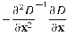 (3)
If the function value at z is below a threshold value then this point is excluded. This removes extrema with low contrast. To eliminate extrema based on poor localisation it is noted that in these cases there is a large principle curvature across the edge but a small curvature in the perpendicular direction in the difference of Gaussian function. If this difference is below the ratio of largest to smallest eigenvector, from the 2x2 Hessian matrix at the location and scale of the keypoint, the keypoint is rejected.

- Orientation Assignment:
This step aims to assign a consistent orientation to the keypoints based on local image properties. The keypoint descriptor, described below, can then be represented relative to this orientation, achieving invariance to rotation. The approach taken to find an orientation is:
Use the keypoints scale to select the Gaussian smoothed image L, from above
Compute gradient magnitude, m
(3)
Compute orientation, θ
(4)
Form an orientation histogram from gradient orientations of sample points
Locate the highest peak in the histogram. Use this peak and any other local peak within 80% of the height of this peak to create a keypoint with that orientation
Some points will be assigned multiple orientations
Fit a parabola to the 3 histogram values closest to each peak to interpolate the peaks position

- Keypoint Descriptor:
The local gradient data, used above, is also used to create keypoint descriptors. The gradient information is rotated to line up with the orientation of the keypoint and then weighted by a Gaussian with variance of 1.5 * keypoint scale. This data is then used to create a set of histograms over a window centred on the keypoint.

Keypoint descriptors typically uses a set of 16 histograms, aligned in a 4x4 grid, each with 8 orientation bins, one for each of the main compass directions and one for each of the mid-points of these directions. This results in a feature vector containing 128 elements.

The feature set of the above two procedures are then combined together to form the resultant vector used in the steps further to train the model. This was done to improve the accuracy of the result by including more features in our vector [16].
The dataset is then divided into training and testing as 75% and 25% respectively.

- Detection and Classification:

The classifiers used to obtain the results and for the comparative study are as follows
  - Support vector Machine [23]:

Support vector machines (SVMs) are powerful yet flexible supervised machine learning algorithms which are used both for classification and regression.
The main goal of SVM is to divide the datasets into classes to find a maximum marginal hyperplane (MMH) and it can be done in the following two steps −
- First, SVM will generate hyperplanes iteratively that segregates the classes in best way.
- Then, it will choose the hyperplane that separates the classes correctly.
SVM algorithm is implemented with kernel that transforms an input data space into the required form. SVM uses a technique called the kernel trick in which kernel takes a low dimensional input space and transforms it into a higher dimensional space

Linear Kernel
It can be used as a dot product between any two observations. The formula of linear kernel is as below −
K(x,xi)=sum(x∗xi)K(x,xi)=sum(x∗xi) (5)
From the above formula, we can see that the product between two vectors say 𝑥 & 𝑥𝑖 is the sum of the multiplication of each pair of input values.
Polynomial Kernel
It is more generalized form of linear kernel and distinguish curved or nonlinear input space. Following is the formula for polynomial kernel –

k(X,Xi)=1+sum(X∗Xi)^dk(X,Xi)=1+sum(X∗Xi)^d (6)
Here d is the degree of polynomial, which we need to specify manually in the learning algorithm.
Radial Basis Function (RBF) Kernel
RBF kernel, mostly used in SVM classification, maps input space in indefinite dimensional space. Following formula explains it mathematically −
K(x,xi)=exp(−gamma∗sum(x−xi^2))K(x,xi)=exp(−gamma∗sum(x−xi^2)) (7)
Here, gamma ranges from 0 to 1. We need to manually specify it in the learning algorithm. A good default value of gamma is 0.1.

  - Logistic Regression [24]:

Logistic regression is a supervised learning classification algorithm used to predict the probability of a target variable. The nature of target or dependent variable is dichotomous, which means there would be only two possible classes.
In simple words, the dependent variable is binary in nature having data coded as either 1 (stands for success/yes) or 0 (stands for failure/no).
Mathematically, a logistic regression model predicts P(Y=1) as a function of X.

The Logistic regression equation can be obtained from the Linear Regression equation. The mathematical steps to get Logistic Regression equations are given below:
We know the equation of the straight line can be written as:

y = b₀ + b₁x₁ + b₂x₂ + b₃x₃ + … + b_{n}x_{n} (6)
In Logistic Regression y can be between 0 and 1 only, so for this let's divide the above equation by (1-y):

y ; 0 for y = 0 and infinity for y = 1 (7)
1 - y
But we need range between -[infinity] to +[infinity], then take logarithm of the equation it will become:
Log[y /1 - y ] = b₀ + b₁x₁ + b₂x₂ + b₃x₃ + ….. + b_{n}x_{n} (8)
The above equation is the final equation for Logistic Regression

  - Random Forest [25]:

Random forest is a supervised learning algorithm which is used for both classification as well as regression. But however, it is mainly used for classification problems. As we know that a forest is made up of trees and more trees means more robust forest. Similarly, random forest algorithm creates decision trees on data samples and then gets the prediction from each of them and finally selects the best solution by means of voting. It is an ensemble method which is better than a single decision tree because it reduces the over-fitting by averaging the result.
Working of Random Forest Algorithm:
We can understand the working of Random Forest algorithm with the help of following steps:

Step 1 − First, start with the selection of random samples from a given dataset.
Step 2 − Next, this algorithm will construct a decision tree for every sample. Then it will get the prediction result from every decision tree.
Step 3 − In this step, voting will be performed for every predicted result.
Step 4 − At last, select the most voted prediction result as the final prediction result.

  - K-Nearest Neighbor [26]:

K-nearest neighbors (KNN) algorithm is a type of supervised ML algorithm which can be used for both classification as well as regression predictive problems. However, it is mainly used for classification predictive problems in industry.

Working of KNN Algorithm:

K-nearest neighbors (KNN) algorithm uses ‘feature similarity’ to predict the values of new datapoints which further means that the new data point will be assigned a value based on how closely it matches the points in the training set. We can understand its working with the help of following steps:

Step 1 − For implementing any algorithm, we need dataset. So, during the first step of KNN, we must load the training as well as test data.

Step 2 − Next, we need to choose the value of K i.e. the nearest data points. K can be any integer.

Step 3 − For each point in the test data do the following:
3.1 − Calculate the distance between test data and each row of training data with the help of any of the method namely: Euclidean, Manhattan or Hamming distance. The most commonly used method to calculate distance is Euclidean.
3.2 − Now, based on the distance value, sort them in ascending order.
3.3 − Next, it will choose the top K rows from the sorted array.
3.4 − Now, it will assign a class to the test point based on most frequent class of these
rows.

Step 4 – End

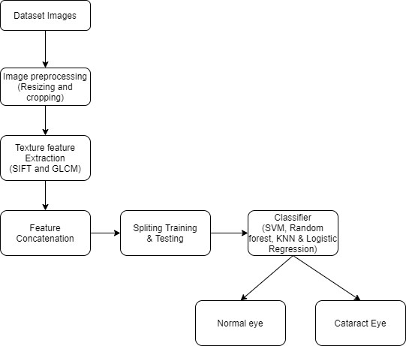

Fig 9. Flow chart of proposed system

Implementation & Results:

For the implementation environment the following have been used:
- Hardware: 8GB RAM Windows OS system
- Software: Python 3.8, Jupyter Notebook, OpenCV and other
Machine learning packages.
The dataset of 97 images are cropped manually in the initial stage and then they are resized to 128pixels followed by grayscale conversion of the images which are then used for texture feature extraction.
Maximum accuracy is obtained when texture features extracted from SIFT and GLCM are combined and used together. The total number of features in SIFT and GLCM were 2303 and 5 respectively accounting for a total of 2308. The results of accuracies obtained are demonstrated in the table below

Table No.9 Comparison of various classifiers

Feature Extraction  Classifier | SIFT | GLCM | SIFT + GLCM
SVM-LINEAR | 92% | 76% | 96%
SVM-RBF | 92% | 56% | 96%
RANDOM FOREST | 84% | 64% | 96%
LOGISITIC REGRESSION | 92% | 80% | 96%
KNN | 68% | 60% | 56%

Conclusion

In this project, various machine learning algorithms have been proposed for the Cataract detection. For this, we have used texture features. We have used a new set of features by combined two set of features: SIFT (Scale Invariant Feature Transform) and GLCM (Gray Level Cooccurrence Matrix). Thus, the new set of features have been obtained and used for Cataract prediction. The various algorithms proposed in our project are SVM(Linear), SVM(RBF), KNN, Logistic Regression, Random Forest. Out of which the highest accuracy achieved is 96%. In conclusion, the combined set of features have obtained better results than the individual features.

References

[1] M. R. Supriyanti, M. H. Habe, and M. M. Kidode, Normal Eye vs Cataract Eye. 2012 [Online]. Available: https://www.intechopen.com/books/ocular-diseases/utilization-of-portable-digital-camera-for-detecting-cataract

[2] ” Blindness and vision impairment” 12 October 2017: World Sight Day https://www.who.int/blindness/world_sight_day/2017/en/

[3] “Down to earth survey” 10 October 2019 https://www.downtoearth.org.in/news/health/cataract-top-cause-of-blindness-in-india-finds-survey-67187

[4] “cataracts by Mayo Clinic” https://www.mayoclinic.org/diseases-conditions/cataracts/symptoms-causes/syc-20353790

[5] Nuclear Cataract(Feb 07,2019)< https://fb.ru/article/443574/yadernaya-katarakta-simptomyi-prichinyi-lechenie-i-profilaktika>

[6] Cortical Cataract(Dec 09,2014)< https://www.columbiaeye.org/education/digital-reference-of-ophthalmology/lens-cataract/cataract/cortical>

[7] Posterior subcapsular cataracts(Feb 14,2014)< http://webeye.ophth.uiowa.edu/eyeforum/cases/128-Posterior-Polar-Cataract.htm>

[8] Chart used for acuity test(Jan 10,2015)<https://www.zazzle.com/health+mousepads?rf=238177452029091674&tc=2280303>

[9] Slit-lamp examination, Nov 04,2014 <http://www.webdicine.com/drooping-eyelid-part-2.html>

[10] Fundus image obtained after retinal exam(16August,2006)< https://www.reviewofophthalmology.com/article/cataract-complications-the-retinal-perspective>

[11] “Recent Approaches for Automatic Cataract Detection Analysis Using Image Processing” Journal of Network Communications and Emerging Technologies (JNCET), October (2017)

[12] “Remote Automated Cataract Detection System Based on Fundus Images” International Journal of Innovative Research in Science, Engineering and Technology (June 2016)

[13]” Automatic Retinal Disease Classification Using Machine Learning and AI”

[14]” Cataract Detection using Smartphone” Journal of Network Communications and Emerging Technologies (JNCET), December (2017)

[15]" Instant Detection of Cataracts"

[16] X. Qian, E. W. Patton, J. Swaney, Q. Xing and T. Zeng, "Machine Learning on Cataracts Classification Using SqueezeNet," 2018 4th International Conference on Universal Village (UV), Boston, MA, USA, 2018, pp. 1-3, doi: 10.1109/UV.2018.8642133.

[17] N. Hnoohom and A. Jitpattanakul, "Comparison of Ensemble Learning Algorithms for Cataract Detection from Fundus Images," 2017 21st International Computer Science and Engineering Conference (ICSEC), Bangkok, 2017, pp. 1-5, doi: 10.1109/ICSEC.2017.8443900.

[18] J. Ran, K. Niu, Z. He, H. Zhang and H. Song, "Cataract Detection and Grading Based on Combination of Deep Convolutional Neural Network and Random Forests," 2018 International Conference on Network Infrastructure and Digital Content (IC-NIDC), Guiyang, 2018, pp. 155-159, doi: 10.1109/ICNIDC.2018.8525852.

[19] Tawfik, Hadeer R. M., Rania Ahmed Kadry Abdel Gawad Birry and Amani A. Saad. “Early Recognition and Grading of Cataract Using a Combined Log Gabor/Discrete Wavelet Transform with ANN and SVM.” (2018).

[20] Agarwal, V., Gupta, V., Vashisht, V. M., Sharma, K., & Sharma, N. (2019). Mobile Application Based Cataract Detection System. 2019 3rd International Conference on Trends in Electronics and Informatics (ICOEI). doi:10.1109/icoei.2019.8862774

[21] A. B. Jagadale, S. S. Sonavane and D. V. Jadav, "Computer Aided System For Early Detection Of Nuclear Cataract Using Circle Hough Transform," 2019 3rd International Conference on Trends in Electronics and Informatics (ICOEI), Tirunelveli, India, 2019, pp. 1009-1012, doi: 10.1109/ICOEI.2019.8862595.

[22] “Texture Analysis Using the Gray-Level Co-Occurrence Matrix (GLCM)”
https://www.mathworks.com/help/images/texture-analysis-using-the-gray-level-co-occurrence-matrix-glcm.html

[23] “SIFT Image Features” http://homepages.inf.ed.ac.uk/rbf/CVonline/LOCAL_COPIES/AV0405/MURRAY/SIFT.html

[24] “ML - Support Vector Machine(SVM)” https://www.tutorialspoint.com/machine_learning_with_python/machine_learning_with_python_classification_algorithms_support_vector_machine.htm

[25] “Machine Learning – Logistic Regression” https://www.tutorialspoint.com/machine_learning_with_python/machine_learning_with_python_classification_algorithms_logistic_regression.htm

[26]” Classification Algorithms – Random Forest”
https://www.tutorialspoint.com/machine_learning_with_python/machine_learning_with_python_classification_algorithms_random_forest.htm

[27] “KNN Algorithm - Finding Nearest Neighbors”
https://www.tutorialspoint.com/machine_learning_with_python/machine_learning_with_python_knn_algorithm_finding_nearest_neighbors.htm

32

